Fiona O’Donovan and Clodagh O Dea, Mount Sackville
Social Networks in Secondary School

ESAT BT Young Scientist Competition 2004



Social Networks in Secondary School
Project for ESAT BT Young Scientist competition 2004 by Fiona O’Donovan and Clodagh O Dea of Mount Sackville school.
Introduction
Friendships are very important. There is an old saying that “it is not what you know but who you know that matters”. Social networks are formal records of who is friendly with whom. You would not expect to get much help from a stranger, but you can normally count on lots of help from your friends.
If someone has lots of friends they be very powerful because there are many people who they can influence. Also they can hope to get lots of support and help from their large circle of friends. On the other hand if someone has very few friends they can be isolated with nobody that they can influence or ask for help.
It is not only how many friends you have that counts. Sometimes the social network can consist of a group of tightly connected cliques where everyone in the cliques are very friendly with each other, but they have very few friends outside of the clique. The healthiest type of social network is one where everyone has a good number of friends and these friendship ties are fairly evenly spread throughout the whole group.
This project analyses the social networks among first year and sixth year students in our school. Students come to our school from a wide variety of different primary schools and therefore we would expect that the social network of the first years might contain mostly cliques of friends representing the primary school that they attended. By sixth year, however, we would expect that the students would have lots of chance to make a variety of friends. The social network should not contain as many cliques. Any cliques that remain in sixth year should be made up by a common interest such as the type of music they like.
Social networks are analyzed by looking at a few measurements:
- Degree is the number of friends a particular person in the network has.
- Sometimes friendships run in both directions, these friendship ties are symmetrical. We say that there is a symmetrical friendship tie between two people A and B if A considers person B to be their friend and B considers A to be their friend. However, it is also possible for a friendship tie to be asymmetrical. We say that there is an asymmetrical friendship tie between two people A and B if A considers person B to be their friend but B does not consider A to be their friend.
- In the case of asymmetrical relationships it is not enough to count the degree for each person. Instead we must separately calculate the in-degree (how many people consider them to be their friend) and out-degree (how many people do they consider to be their friend).
- People with very high degree measures, are called hubs, this is because most messages will pass through these people. On the other hand people with a zero degree measure are called isolates because they have no friends. These people are unlikely to hear rumours that might be known to most others in the class also they have nobody to ask for help. Another important type of person is a cut-point. These are people who are the only connection between two different parts of the class. If these people leave the class or are simply out of school for some time, they will cause some people to become isolated from the rest of the class.
These measurements will be easier to understand by looking at a few realistic examples.
Methods
We expected that people would be reluctance to openly tell us about whom they considered to be friends (or even more importantly to reveal who they did not count as a friend). Therefore we created questionnaire forms and we asked our science teacher to get them filled in by each of the classes. We thought that if we girls to list all their friends they would all give us a long list because they would be embarrassed to admit that they did not have lots of friends. However, people can only be close friends with a limited number of people at the same time so we asked them to list the five people that they were most friendly with.
To help keep the results less personal we asked them to identify themselves and their friends by their initials. We were only interested in tracking friendship links within the class so we asked them to only mark an x on the form if one of their five best friends was not in the class. Since we wanted to look at how the structure of the social network was related to the primary school attended and the girl’s taste in music, we also asked them to fill in what school they attended and to list their three favourite bands.
A sample of the forms is included at the back of this report.
We realized that there could be more than one girl in the class with the same initials so we asked people to use a number with the initials to tell them apart (e.g. LN1 and LN2). However, people did not seem to understand this instruction properly. Luckily in most cases the girls with the same initials did not go to the same school so we were still able to tell them apart.
When we got all of the forms filled in, we typed them into the computer and we analyzed the networks using a tool called UCINET. We also used a package called Lotus 1-2-3 to draw various charts.
First Year Network
This chapter will describe the results of the first year survey.
The most popular entertainer among the first year girls was Justin Timberlake who was chosen by 48 girls, next most popular was Beyoncé who was chosen by 45 and Christina Aguilera who was chosen by 33 girls.
A total of 107 girls in first year completed our survey. They went to 33 different primary schools. 20 of the girls were the only one in their class going to a particular primary school. The following chart shows the primary schools attended by at more than 2 first years and how many girls from first year went to each:
Primary School | # of Girls
Mount Sackville | 25
St Brigids | 13
Scoil Thomáis Laurel Lodge | 11
Scoil Mhuire Lucan | 9
Scoil Bríd Celbridge | 7
St Francis Xavier | 6
Navan Rd | 4
Others | 32

This same information is shown below in the form of a pie chart.
Of the 107 first years 48 (45%) went to the same primary school as their best friend in the class and 59 (55%) went to a different primary school. Also 57 (53%) like the same band as their best friend while 50 (47%) do not share their best friend’s taste in music.
The forms asked the girls to name their five best friends. They could choose people whether they were in the class or not. The first year girls reported an average of 2.9 of their best friends were from the class. The following table and bar chart show how many friends in the class were reported by each girl doing the survey (i.e. their out-degree):
Out Degree | # of girls | percent
0 | 8 | 7.48%
1 | 12 | 11.21%
2 | 13 | 12.15%
3 | 35 | 32.71%
4 | 28 | 26.17%
5 | 11 | 10.28%

The way we made up the survey forms, the girls could choose at most 5 friends. However, each girl could be chosen as a friend by any number of other girls. The following table and bar chart show by how many other girls each girl was chosen as a friend (i.e. the in-degree):
In Degree | # of girls | percentage
0 | 14 | 13.1%
1 | 22 | 20.6%
2 | 18 | 16.8%
3 | 12 | 11.2%
4 | 16 | 15.0%
5 | 13 | 12.1%
6 | 4 | 3.7%
7 | 3 | 2.8%
8 | 3 | 2.8%
9 | 2 | 1.9%

The UCINET software is capable of drawing a picture of the friendship links between girls in the class. In the following diagram we can see that there is a good distribution of friendships between girls in the class with no obvious sign of cliques. Only one girl is isolated (this girl is labelled ms-nkets indicating that her initials are MS and she attended NKETS national school). In addition three girls mc-sb, cb and sd are identified as cut-points (these are drawn with blue dots in the chart); this means that if these girls leave the class they will cause some girls to become isolated.
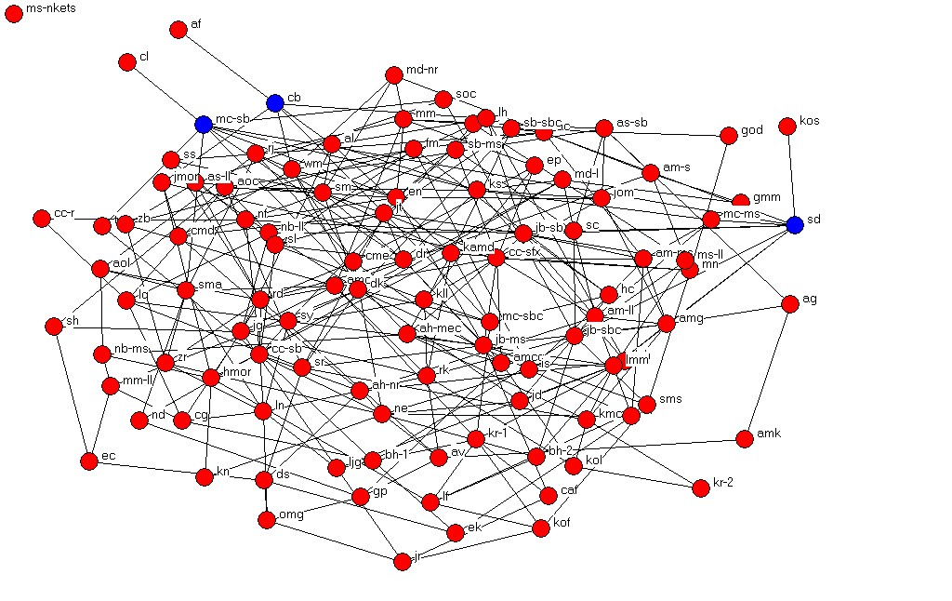
There are no obvious cliques in this network, because most people seem to have different friends than their friends’ friends.
A sign of a really strong friendship is when it is symmetrical. This means that if person A lists person B as a friend, and person B also chooses person A as a friend, then the friendship is symmetrical. The following table and bar chart show how many symmetrical friendship links each girl in the class had.
Symmetric Friendships | # of girls | percentage
0 | 36 | 33.6%
1 | 31 | 29.0%
2 | 30 | 28.0%
3 | 8 | 7.5%
4 | 1 | 0.9%
5 | 1 | 0.9%

We show below the friendship network redrawn such that only symmetric friendship links are considered significant. We see that now a total of fifteen girls are isolated and a further four are disconnected from the main network and only connected to one other girl. A large number of girls are cut-points (identified in the diagram by a red dot).
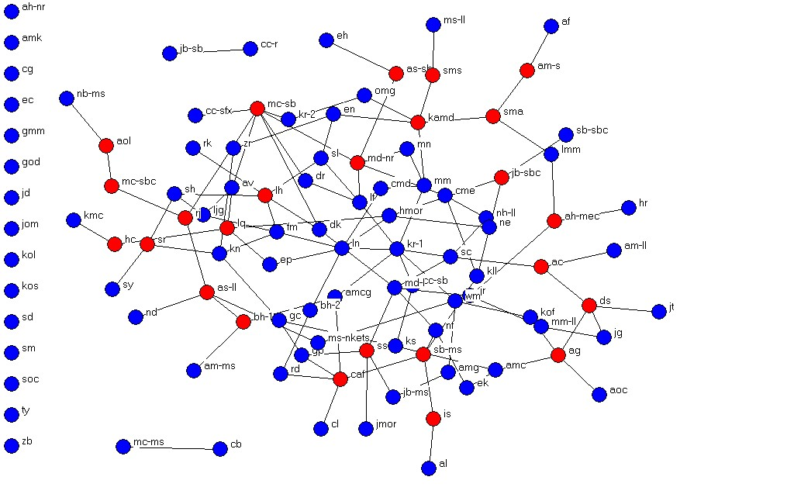
Sixth Year Network
This chapter will describe the results of the sixth year survey.
The most popular entertainer among the sixth year girls was Justin Timberlake who was chosen by 29 girls, next most popular was Britney Spears who was chosen by 14 girls, Beyoncé who was chosen by 11 and Christina Aguilera who was chosen by 7 girls.
A total of 68 girls in sixth year completed our survey. They went to 35 different primary schools. 25 of the girls were the only one in their class going to a particular primary school. The following chart shows the primary schools attended by at least 2 sixth years and how many girls from sixth year went to each:
Primary School | # of girls
Mount Sackville | 14
St Brigids Castleknock | 6
St Francis Xavier | 4
Maynooth | 3
Scoil Bríd Celbridge | 6
Scoil Bhríde | 2
Scoil Íde | 2
Scoil Thomás Laurel Lodge | 2
St Brigids Palmerstown | 2
The Glebe | 2
Other | 25

This same information is shown in the following pie chart:

Of the 68 sixth years 22 (32%) went to the same primary school as their best friend in the class and 46 (68%) went to a different primary school. Also 37 (54%) like the same band as their best friend while 31 (46%) do not share their best friend’s taste in music.
The forms asked the girls to name their five best friends. They could choose people whether they were in the class or not. The sixth year girls reported an average of 2.6 of their best friends were from the class. The following table and bar chart show how many friends in the class were reported by each girl doing the survey (i.e. their out-degree):
Out Degree | # of girls | percentage
0 | 9 | 13.2%
1 | 6 | 8.8%
2 | 13 | 19.1%
3 | 22 | 32.4%
4 | 13 | 19.1%
5 | 5 | 7.4%

The way we made up the survey forms, the girls could choose at most 5 friends. However, each girl could be chosen as a friend by any number of other girls. The following table and bar chart show by how many other girls each girl was chosen as a friend (i.e. the in-degree):
In Degree | # of girls | percentage
0 | 5 | 7.4%
1 | 15 | 22.1%
2 | 18 | 26.5%
3 | 10 | 14.7%
4 | 12 | 17.6%
5 | 5 | 7.4%
6 | 2 | 2.9%
7 | 0 | 0.0%
8 | 0 | 0.0%
9 | 1 | 1.5%

The UCINET software is capable of drawing a picture of the friendship links between girls in the class. In the following diagram we can see that there is a good distribution of friendships between girls in the class with no obvious sign of cliques. Only one girl is isolated (this girl is labelled ns). In addition three girls cc, at and ka are identified as cut-points; this means that if these girls leave the class they will cause some girls to become isolated.
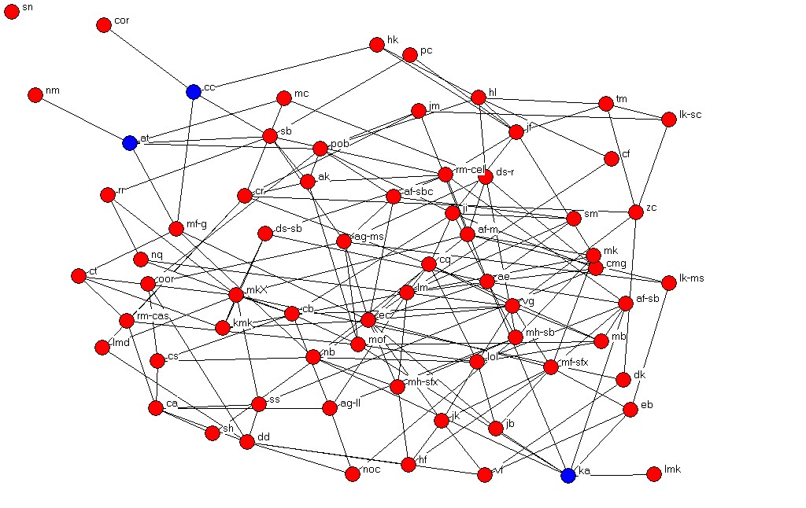
There are no obvious cliques in this network, because most people seem to have different friends than their friends’ friends.
A sign of a really strong friendship is when it is symmetrical. This means that if person A lists person B as a friend, and person B also chooses person A as a friend, then the friendship is symmetrical. The following table and bar chart show how many symmetrical friendship links each girl in the class had.
Symetric Friendships | # of girls | percentage
0 | 18 | 26.5%
1 | 24 | 35.3%
2 | 17 | 25.0%
3 | 8 | 11.8%
4 | 1 | 1.5%
5 | 0 | 0.0%

We show below the friendship network redrawn such that only symmetric friendship links are considered significant. We see that now a total of six girls are isolated. A large number of girls are cut-points (identified in the diagram by a blue dot).
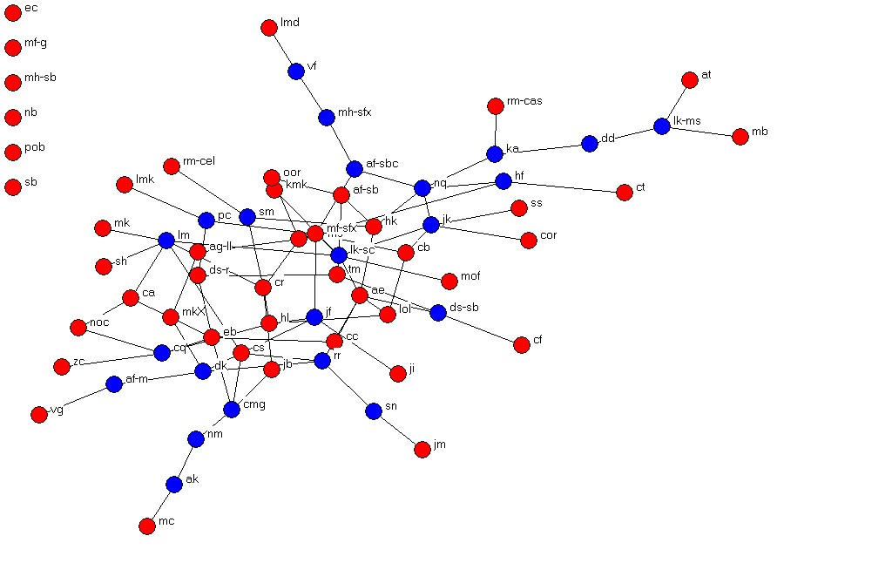
Conclusions
This section will compare the results of the two surveys and will explain our conclusions.
- The most striking fact is that the two friendship networks are so similar. The first year class are only together for two months at the time of the survey, while most of the sixth years would have been together for over 5 years. Nevertheless there were about the same number of friendship links in both classes.
- In sixth year a higher proportion of the friendships are symmetrical. This is possibly because in first year the friendship ties are only just established and probably not as strong a link. 36 of the first years (34%) had no symmetric friendships, but only 18 (26.5%) of sixth years had no symmetric friendships.
- In first year there more variation in the in-degree. Quite a few girls were chosen as friends by nobody, while some girls were chosen as a friend by 9 other girls.
- In first year 45% of girls chose a best friend who went to the same primary school, while only 32% of sixth years chose a best friend who went to the same primary school. However, the percentages choosing a best friend with the same taste in music is more or less the same (53% in first year and 54% in sixth year).
Appendix A – Sample Questionnaires

